# Ilkley Camera Club Competition Software

This document provides instructions on how to run a competition with Tim’s new software.

* Start the software by double clicking the TPhotoComp icon on the desktop.
* It looks for competition files in the c:\TPhotoComp\Competitions directory.
* Each competition is a separate zip file, as provided by Tim.
* Each competition file is named YYYY-MM-DD Competition Title.zip

## Homepage

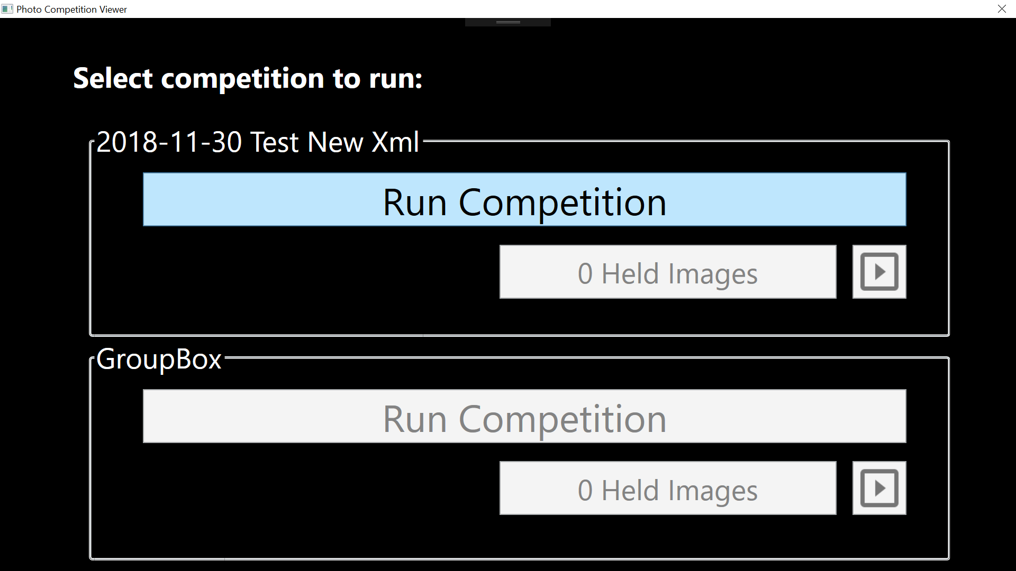

This page will show the next two competitions chronologically by the date of the competition filename. Competitions in the past are not shown.

There are three buttons for each competition:

* **Run Competition**: This will allow the competition images to be viewed in turn
* **Held Images**: Once images are held, this will allow access to them
* **Slideshow**: This will show a slideshow of held images or award winners.
* The **Escape** key can always be used to back out of the window you are in. Pressing it here will close the software.

## Run Competition

This button will first show a title page, with the club name, competition name and trophy. Pressing the Right Arrow key will start the competition and show the first image.

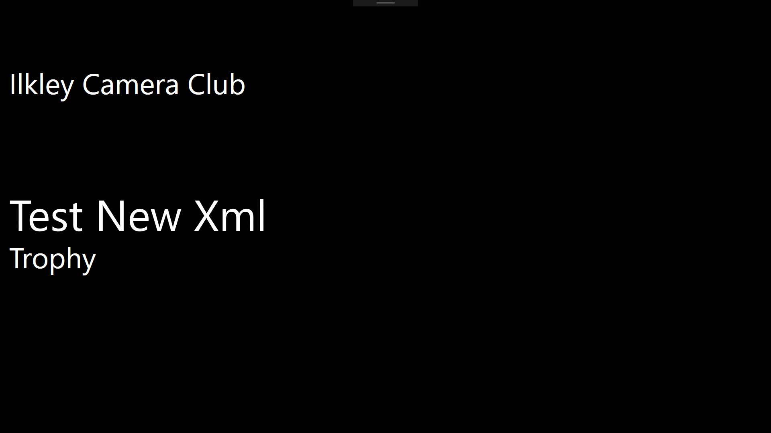

When an image is shown, the image title is overlaid for a short amount of time. In the bottom left hand corner, you will see a progress meter – (1/60). This indicates this is the first image of 60.

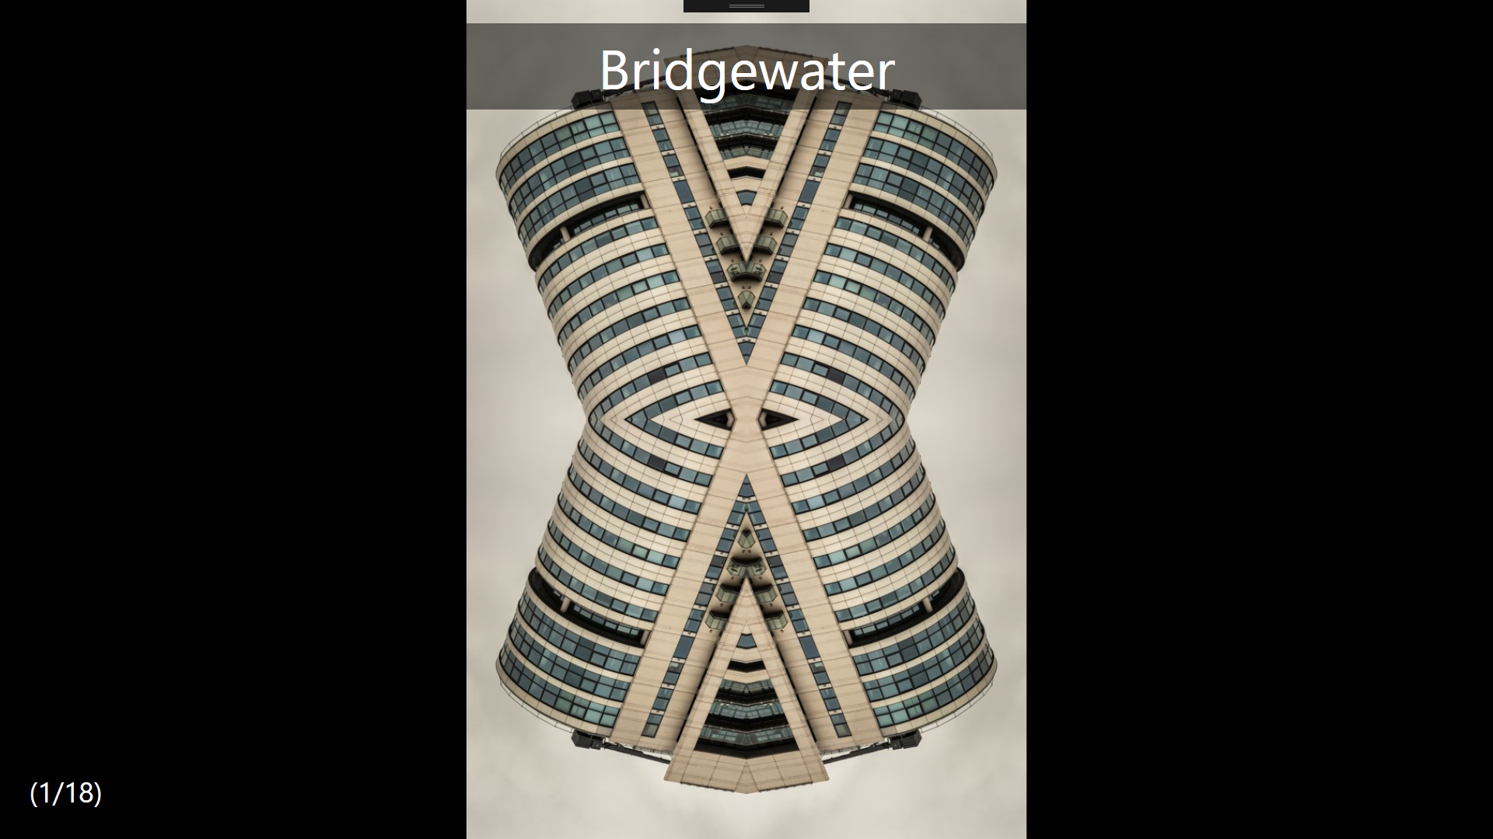

When showing an image, the following keys are available:

* **T** – this will reshow the image title.
* **H** – this will toggle the held status of the image. If the progress indicator shows square brackets [1/60], the image is held. If the progress indicator shows round brackets, (1/60), the image is not held. Toggling the held status will reshow the title of the image for a short period of time.
* **Right arrow** – move to next image
* **Left arrow** – move to previous image
* **Escape** – close competition and move to the Homepage

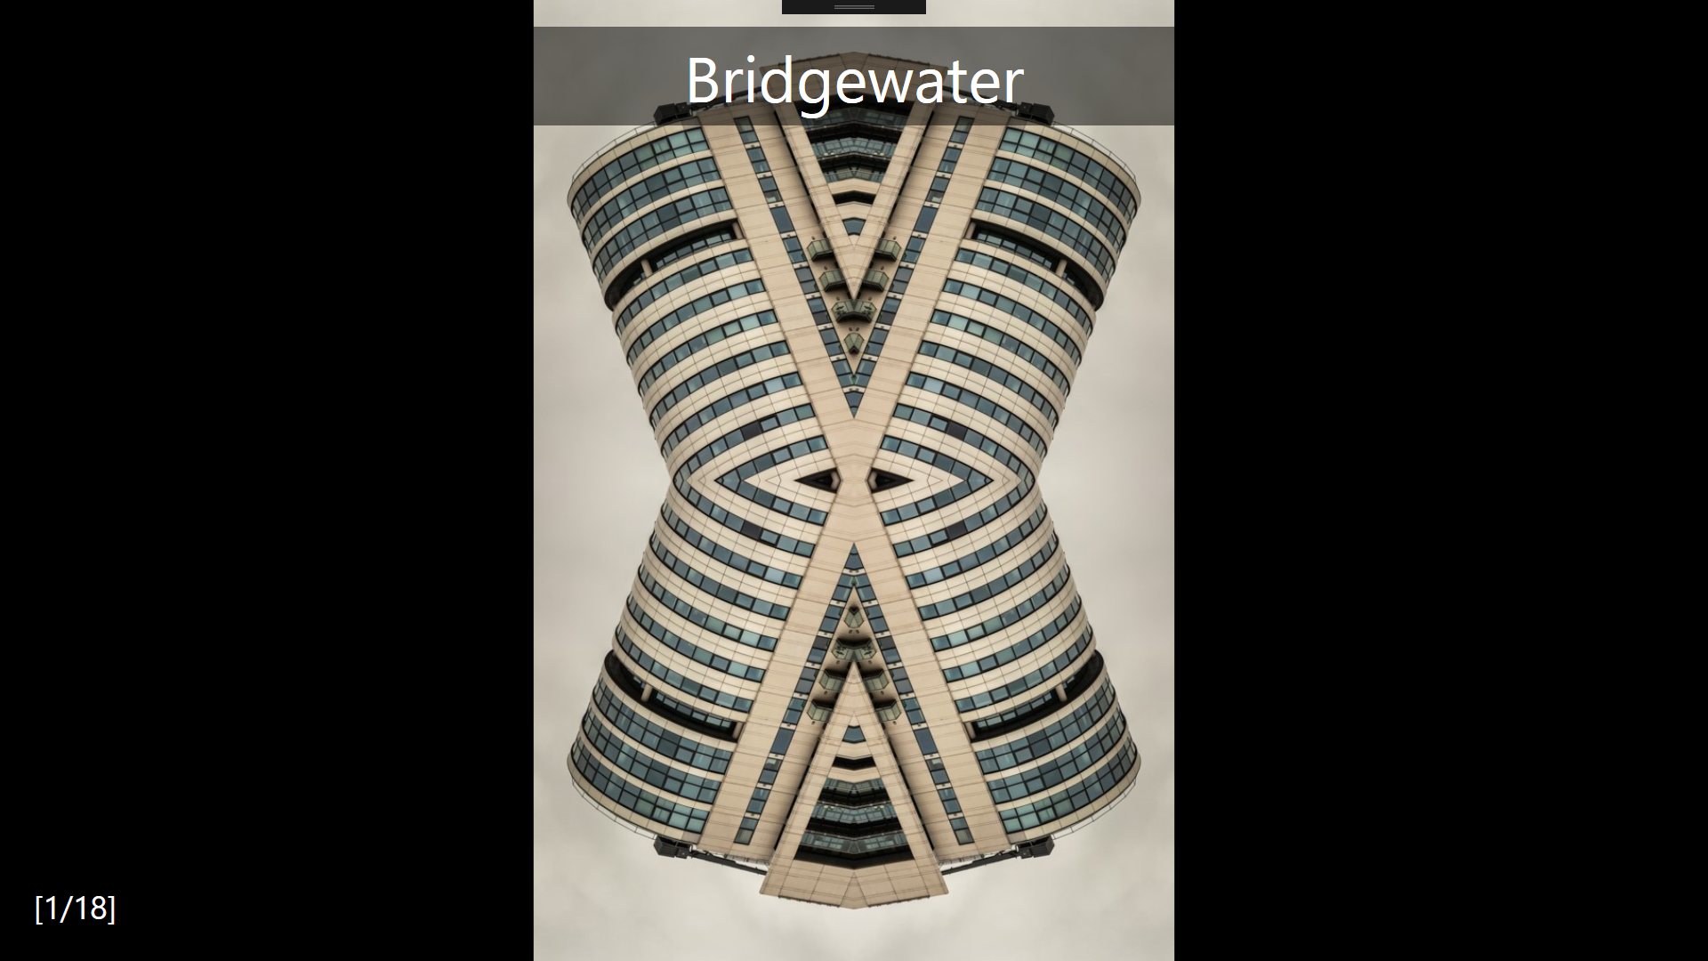

The above image shows a held image – the numbers in the bottom left are inside [square brackets] instead of (round ones).

The presentation clicker can be used by the judge to control the competition.

* **Clicker right arrow** – move to next image
* **Clicker left arrow** – move to previous image
* **Clicker bottom button** – reshow image title

Once there are no more images to show, the message “That’s All Folks” is shown. Press **Escape** to return to the Homepage.

## All Held Images

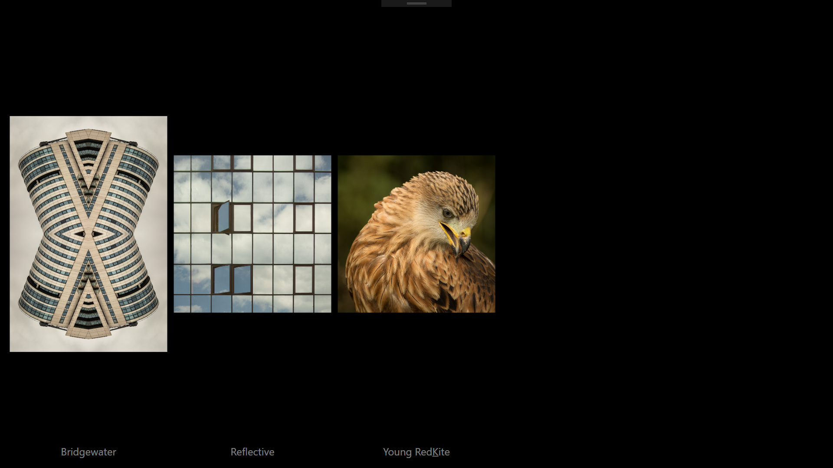

Once images have been held, the Held Images button is enabled. Clicking this will show a page of thumbnails for each held image.

The following keys are available here:

* **Escape** – returns to the Homepage.
* **Ctrl-N** – allows you to enter an image number, and show that image full screen
* **Clicking on an image** will show that image full screen.

Unawarded images are shown first. Awarded images are shown at the bottom of the list, with an indication of the award they’ve been given.

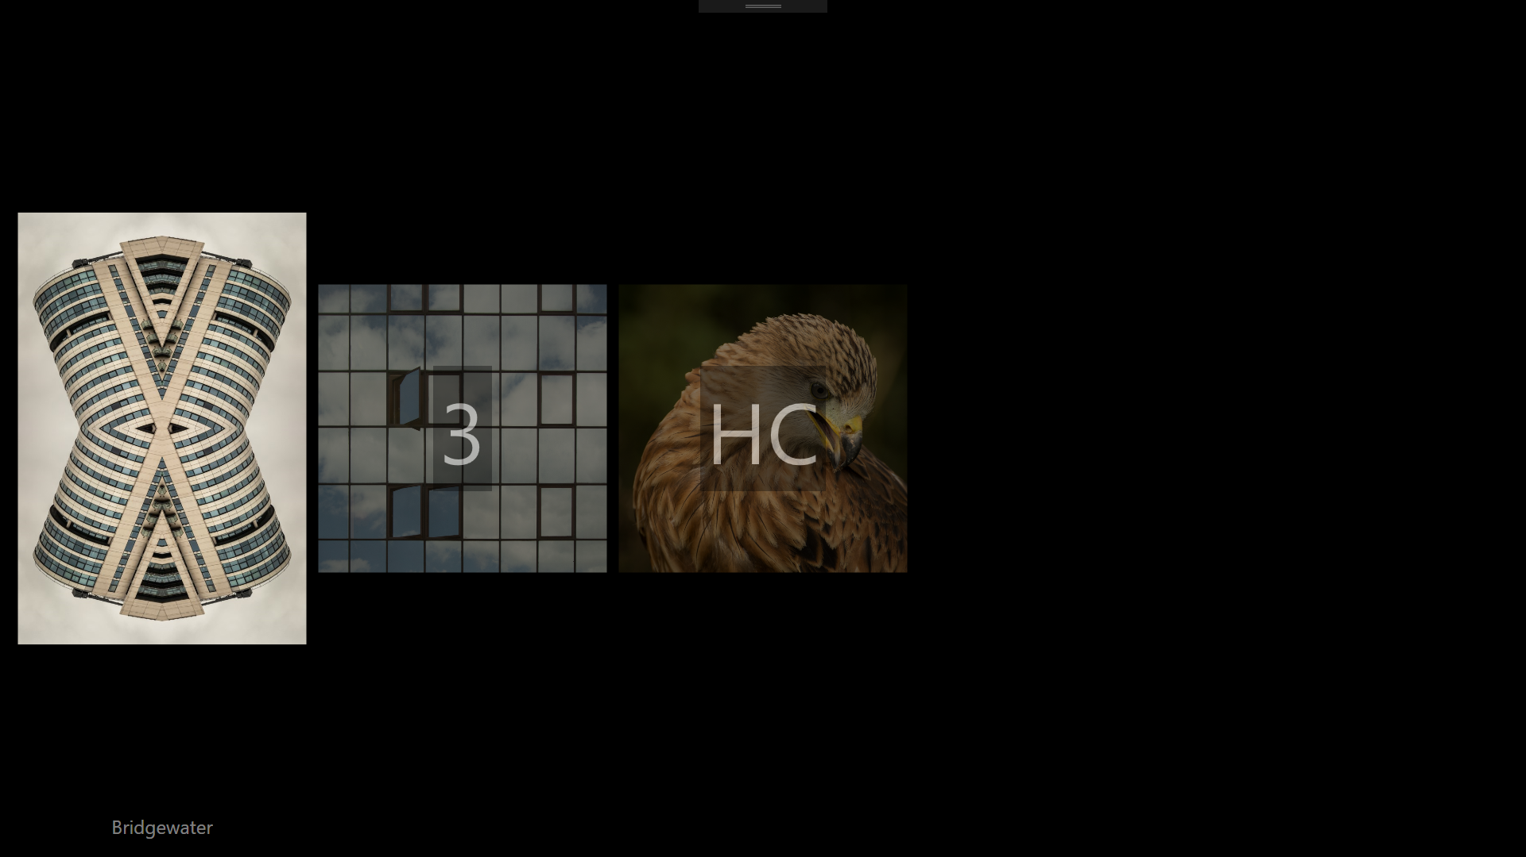

## Single Held Image

When showing a single held image, the following keys are available:

* **Escape** – returns to the All Held Images window.
* **Ctrl-C** – Award the image Commended
* **Ctrl-H** – Award the image Highly Commended
* **Ctrl-3** – Award the image Third Place
* **Ctrl-2** – Award the image Second Place
* **Ctrl-1** – Award the image First Place.
* **Ctrl-0** (zero) – Remove awards for this image

Giving an image an award will show the image author on screen.

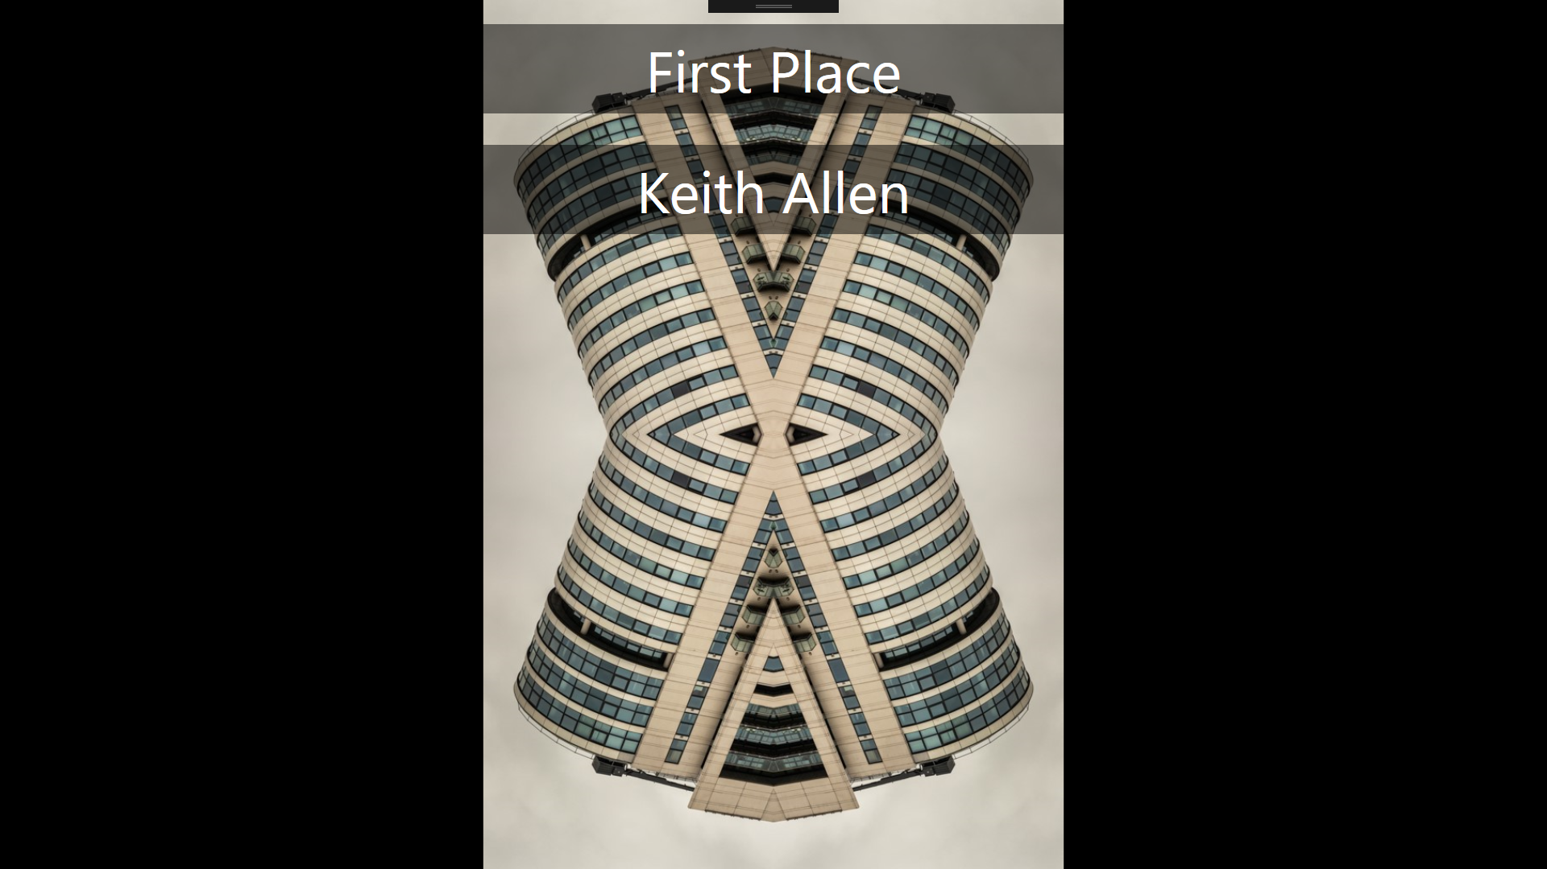

## Slideshow

When images have been held, but none have been awarded the Slideshow option will show each held image in turn, along with its title.

Where images have been given awards, the Slideshow option will show each awarded image in turn, along with its placing, title and author.

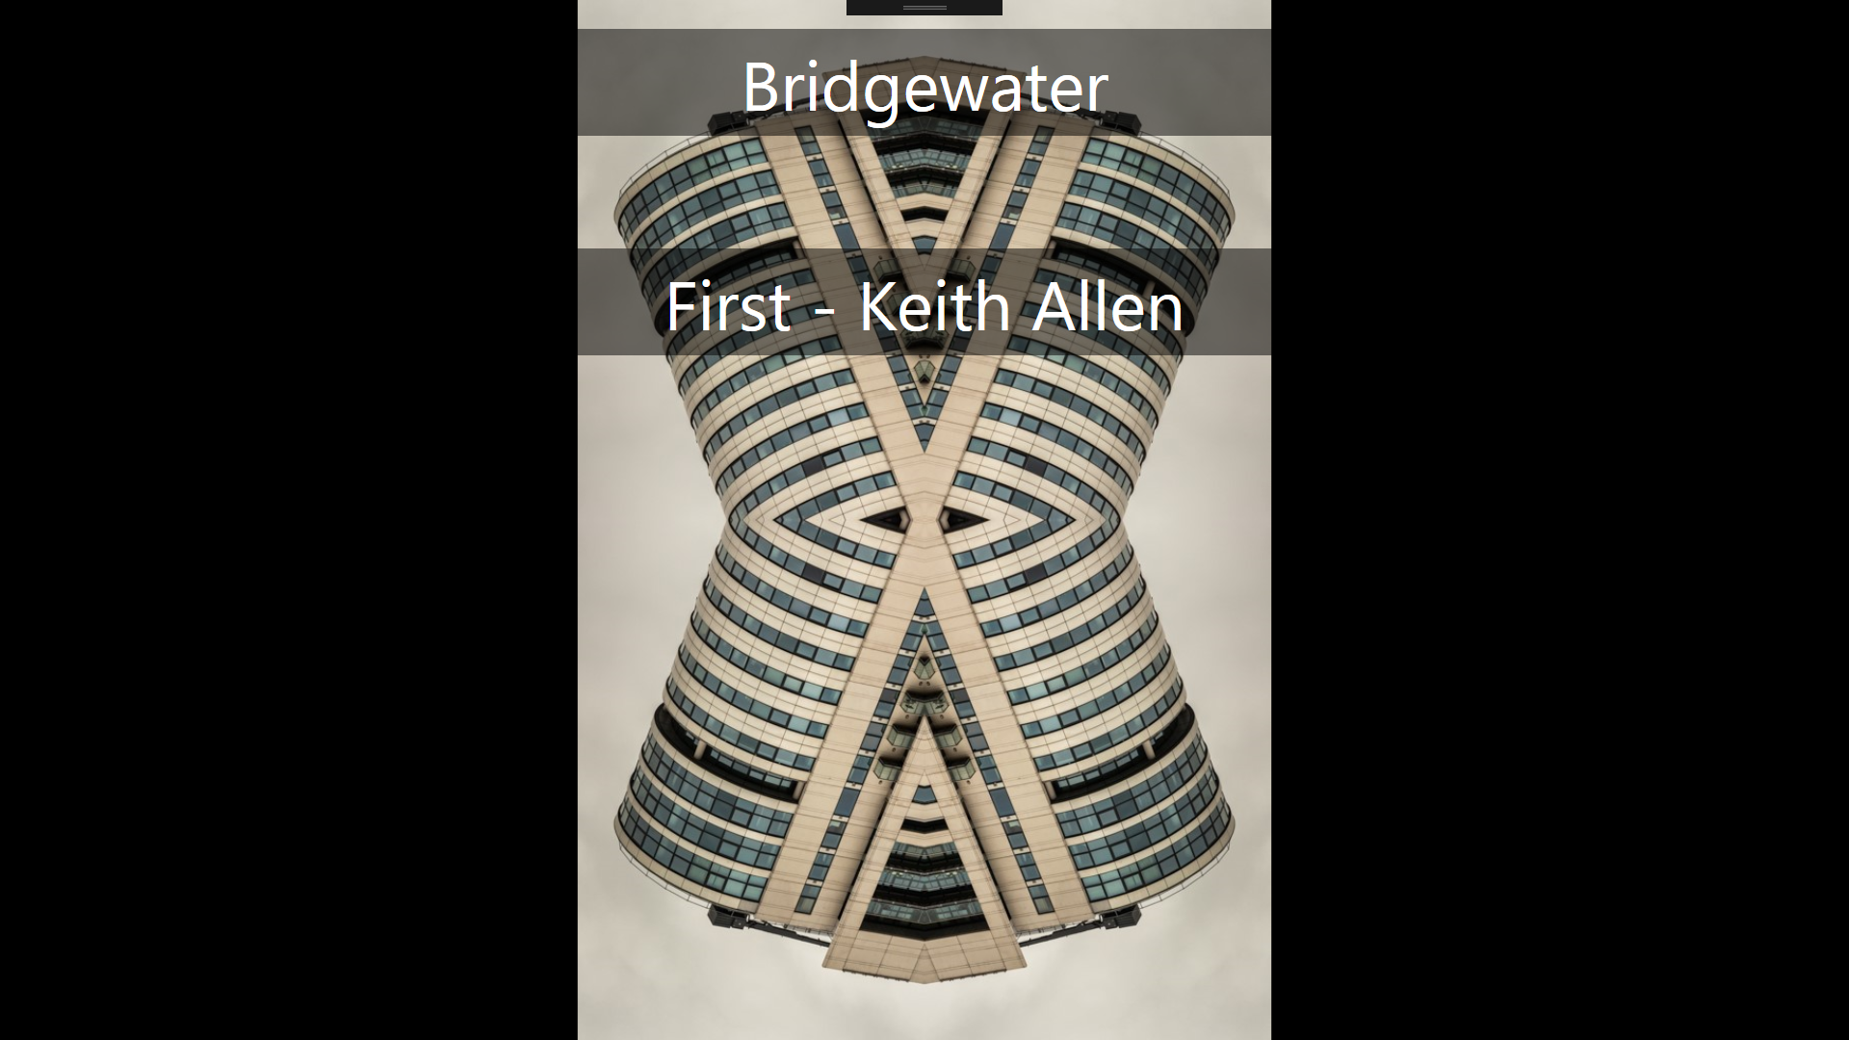

Press **Escape** to exit the slideshow.